This is what SAP 2012 Methodology recognises for Flats and Maisonettes.

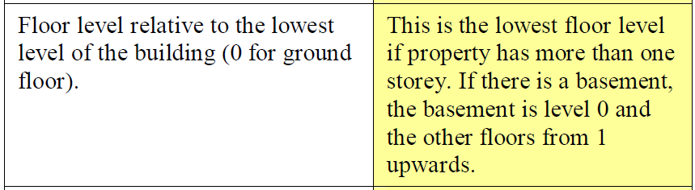

Lifespan RdSAP uses ‘Storey Level’ instead of floor level as it’s terminology, with this in mind:

