**This is the process for RdSAP 9.94 assessments Post Sept 2020 Only:**

Do not delete the Gov UPRN (step 1) before checking the date of the lodgement.

1. Select the property and go to the summary page and then click on edit. The screen below should pop up. In the Gov UPRN section field, if there is current a number in there, a red cross will be at the side where you can delete it. Leave the field blank and save.

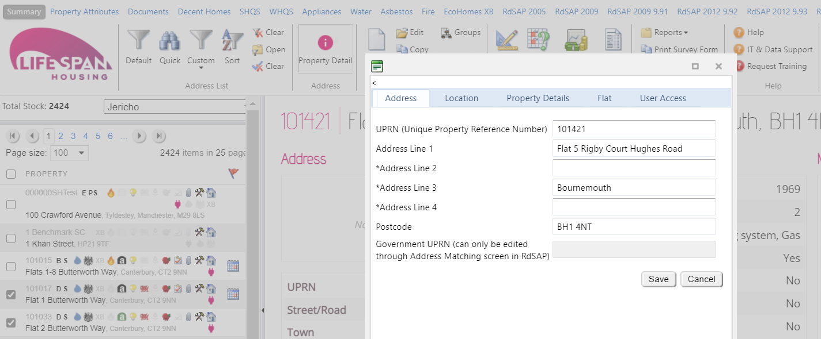

1. Now go to the rdsap 9.94 module
2. Click on address match

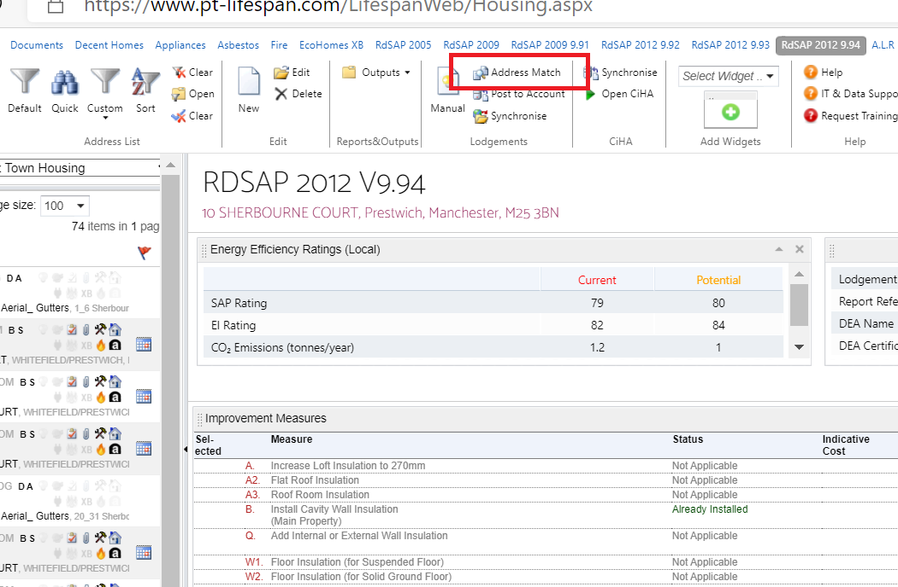

1. If you have a number of ticked properties you want to address match for then select ticked properties but if you are just doing one then select highlighted property and press continue

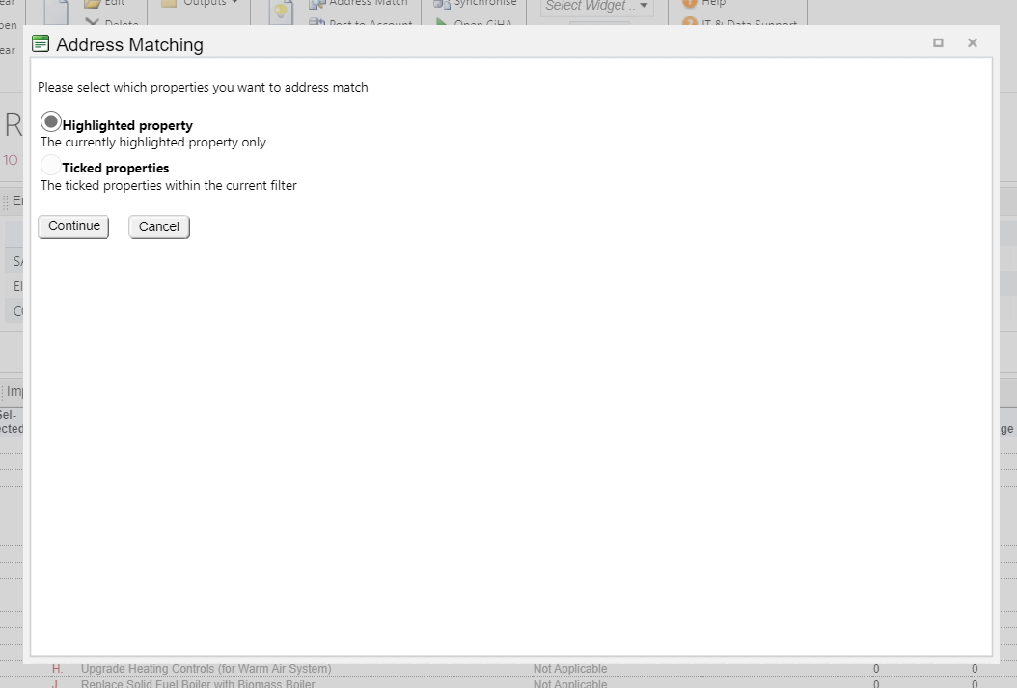

1. For each address it will return a number of addresses. For example in the screenshot below. When you click on the drop down it shows you two options. You need to make sure you select the one that matches your address but also returns the correct UPRN. Since the new register all properties have a UPRN that starts “UPRN” followed by a series of numbers. You can select each address in the drop down until you get the correct one. The UPRN shows in the matched UPRN column. Click on save when you have found the one you need.

To synchonise a epc certificate (can only be done if EPC lodgement is complete and done via Lifespan rdsap)

1. Once matched, click on synchronise.

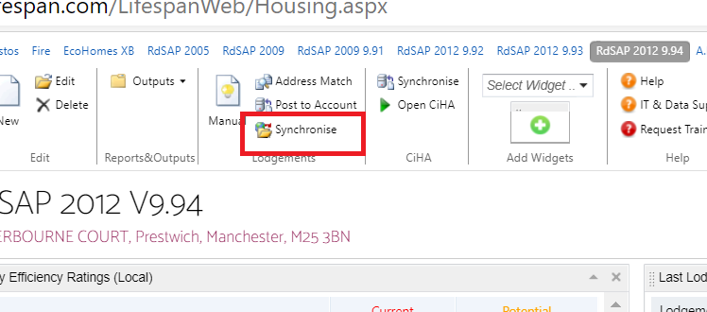

1. Again you can just syncronise against the highlighted property or your ticked properties:

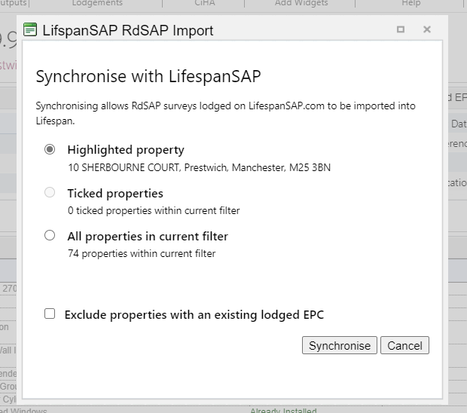

1. If there has been a lodgement against that address in the rdsap version you are in then it will update with the data and show it has been successfully imported:

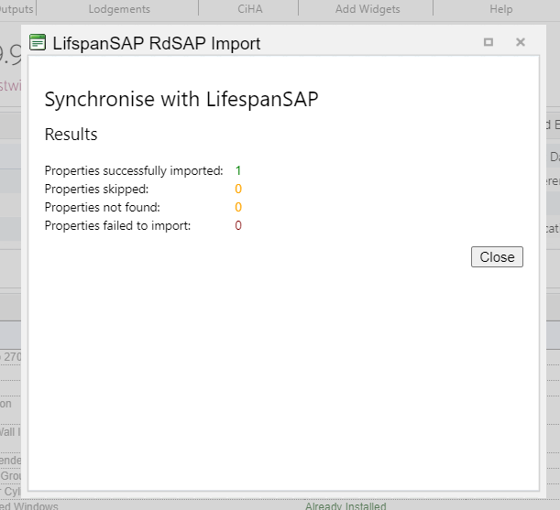

1. You then need to refresh the property in order to view the information