1. Click on an assessment then click on edit

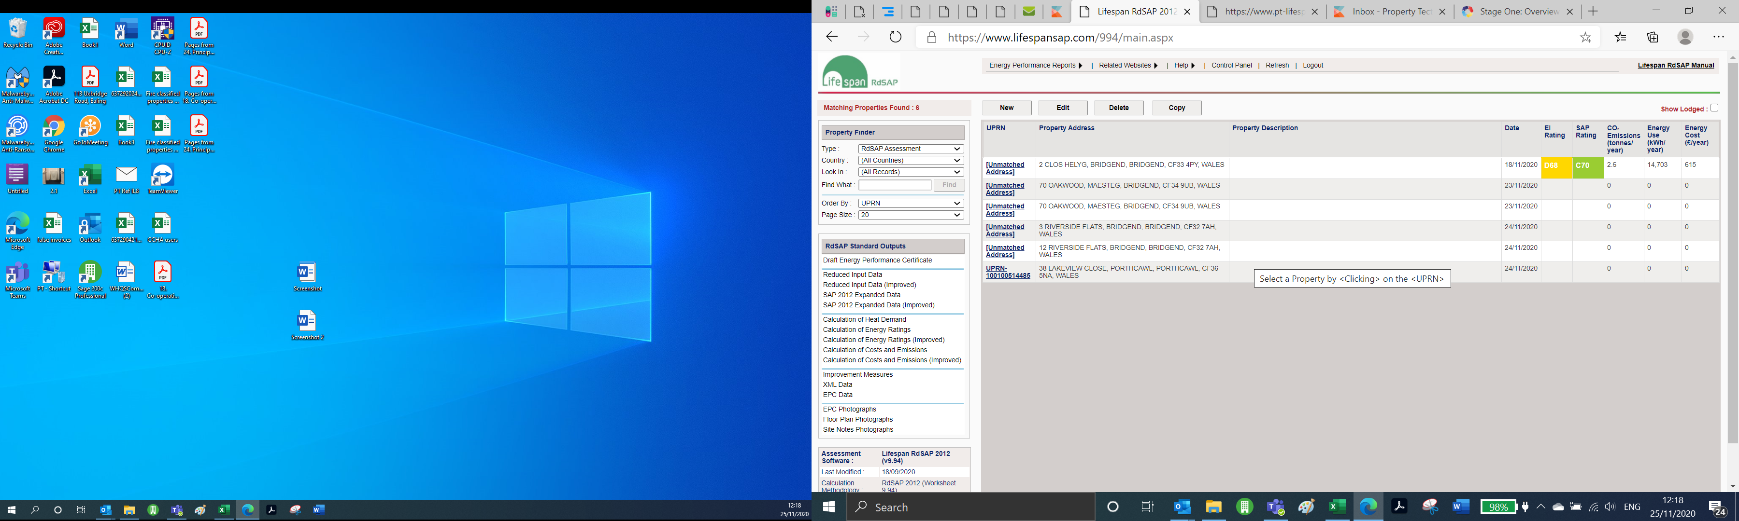

1. Click on Find UPRN and property Address

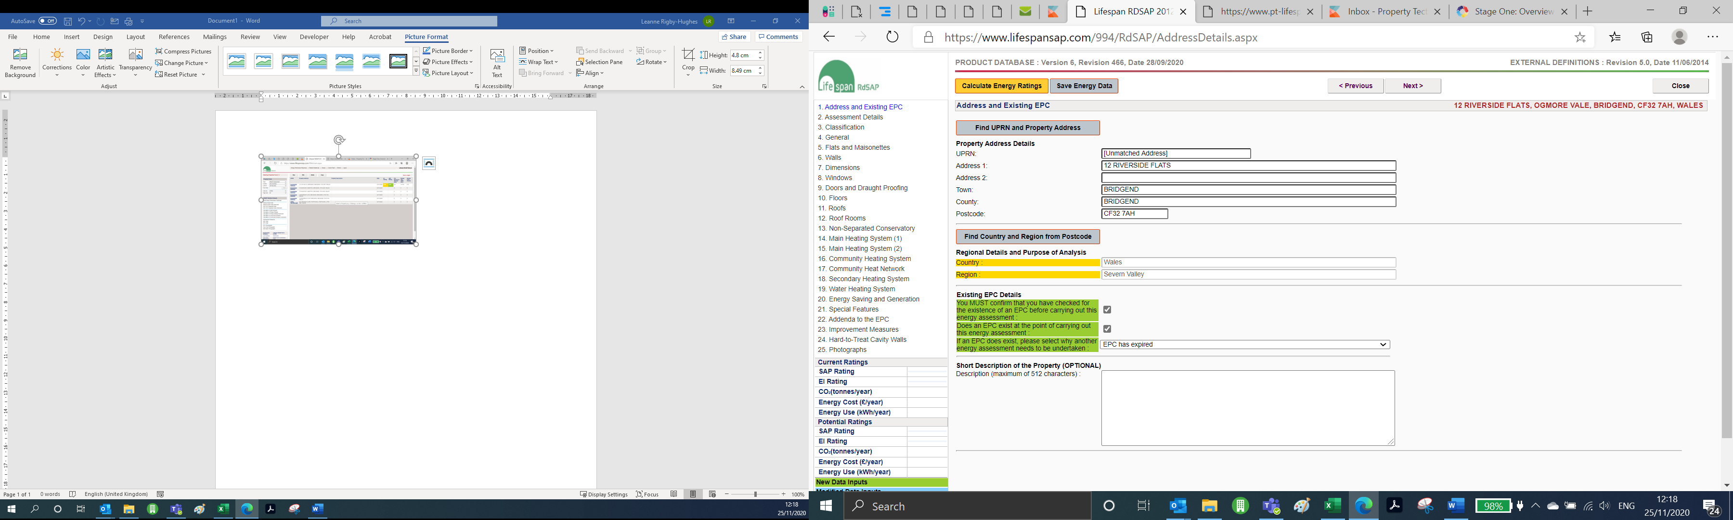

1. Search for the property using the postcode. Find the relevant address in the list. There may a few that come up with the same address. You need to find the one that when you select the address it comes up with a UPRN starting UPRN followed by numbers, as per step 4 below. If for any reason the address does not come up then you need to create a new one, by clicking on manually enter the address at the bottom.

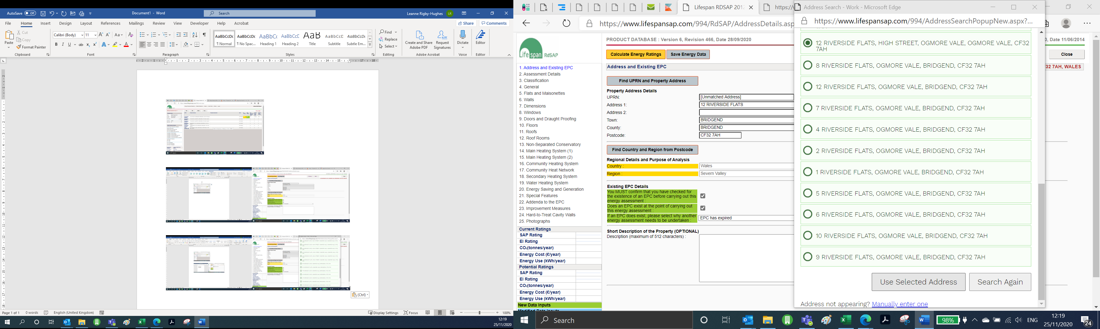

1. Once you have selected the address and it is has the correct UPRN then click on select address

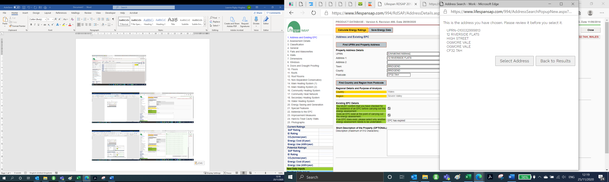

1. Once you have done this and gone back to the screen below. Click on save and then calculate.

