- Click on an assessment then click on edit
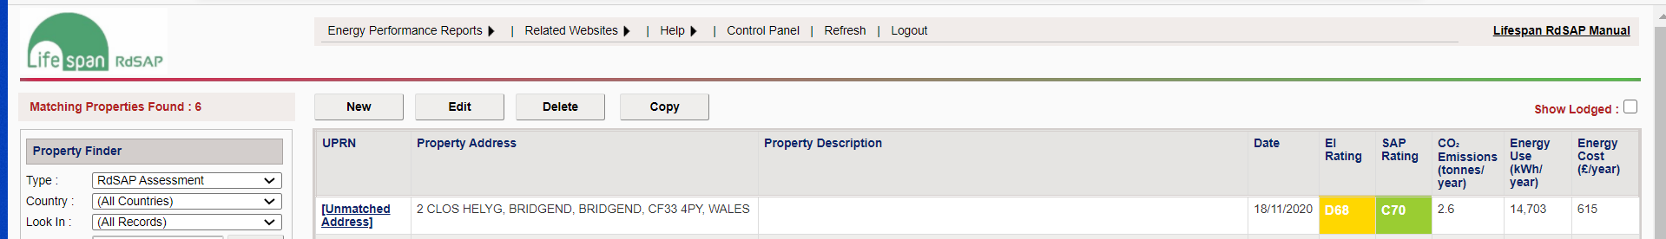

- Click on Find UPRN and property Address

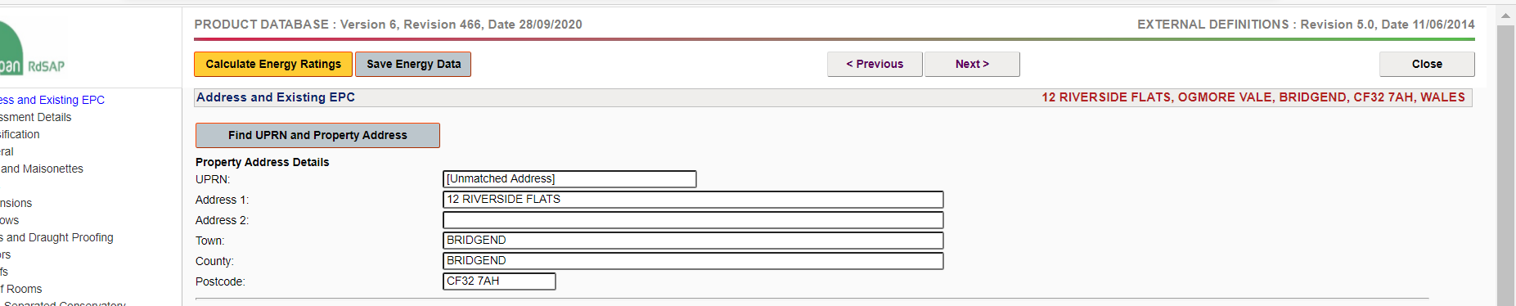

- Search for the property using the postcode. Find the relevant address in the list. There may a few that come up with the same address. You need to find the one that when you select the address it comes up with a UPRN starting UPRN followed by numbers, as per step 4 below. If for any reason the address does not come up then you need to create a new one, by clicking on manually enter the address at the bottom.
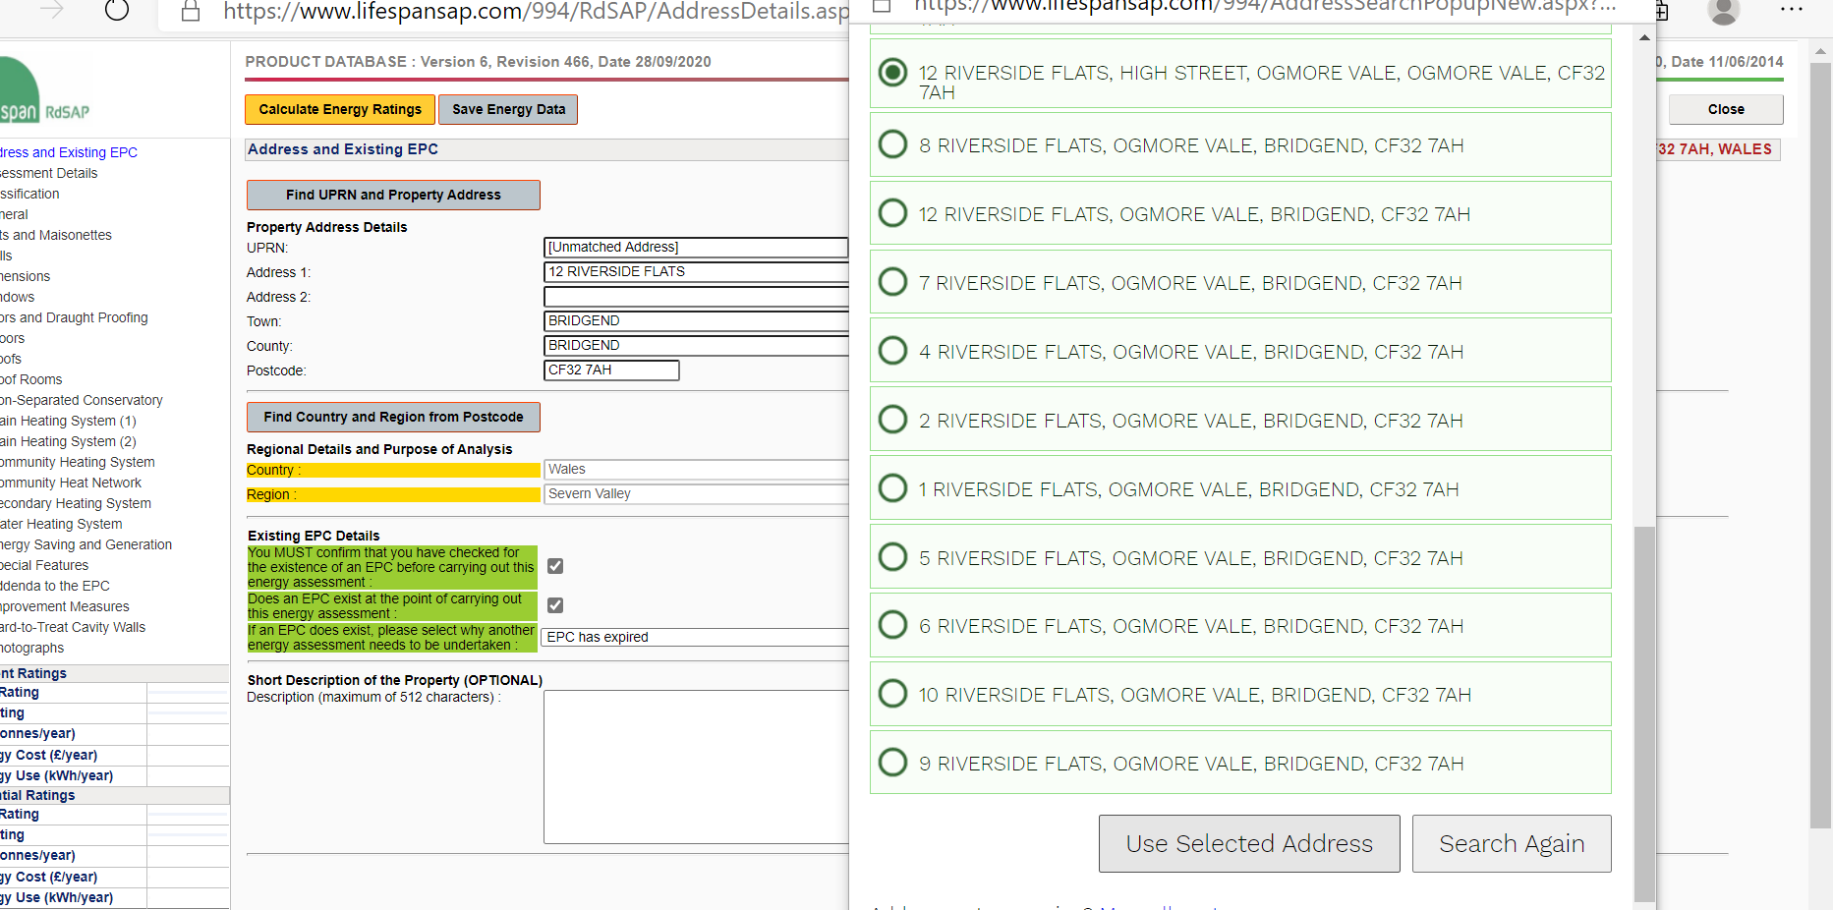

- Once you have selected the address and it is has the correct UPRN then click on select address
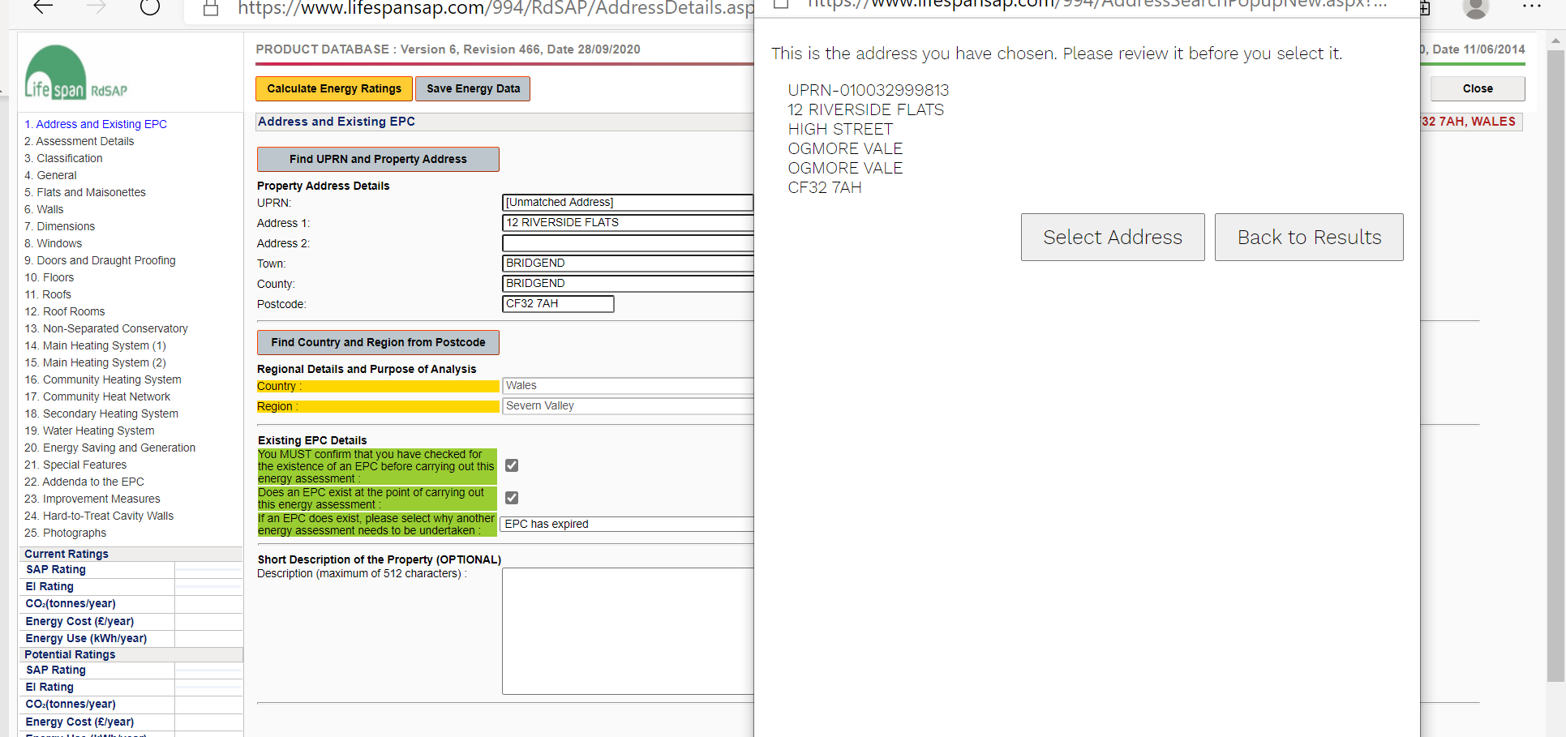
- Once you have done this and gone back to the screen below. Click on save and then calculate.
